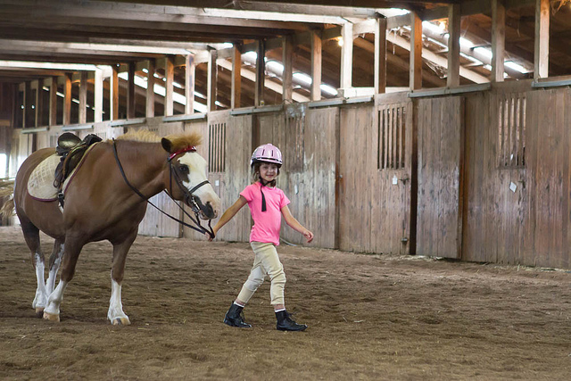

Capriole Academy
September 26, 2016
Dear Parents or Guardians:

I chatted with Angie, our riding instructor from Capriole Academy and she clearly stated that she has no room for lessons on Saturdays. On Sundays she asked us to switch times to the pm so that would mean our lesson starts at 1 pm and ends at 2:30.
We still need to have 6 confirmed riders.
If we have enough riders before this Friday, I will confirm the following Sundays:
October 2
October 16
November 6
November 20
November 27
December 4
Please pay Angie directly. Each lesson is 40.00.
I would confirm the other lessons in late December before we break for the winter.
Thanks for your continued support.
Ms Sinclair

